Testing a Fully Assembled Transceiver

Servicing a SuperDARN Transceiver  
Step 12

Content

1. Introduction 3

2. Instructions 3

3. Shortcut 5

4. Conclusion 6

# Introduction

This document provides work instructions for testing a Fully Assembled Transceiver. Before attempting to implement these instructions, be sure to complete all the preceding steps in the procedure for Servicing a SuperDARN Transceiver.

# Instructions

Following are the step-by-step instructions for testing a Fully Assembled Transceiver. In the case of unforeseen problems occurring, apply electronic fault-finding techniques.

## Preparation

Steps for setting up the test station. Refer to *Figure 1*.

1. Ensure all cables are plugged in.
2. Ensure the dummy load is connected to the antenna port.
3. The Tx/Rx signal on the PWRAMP is being measured on channel 1 on the oscilloscope.

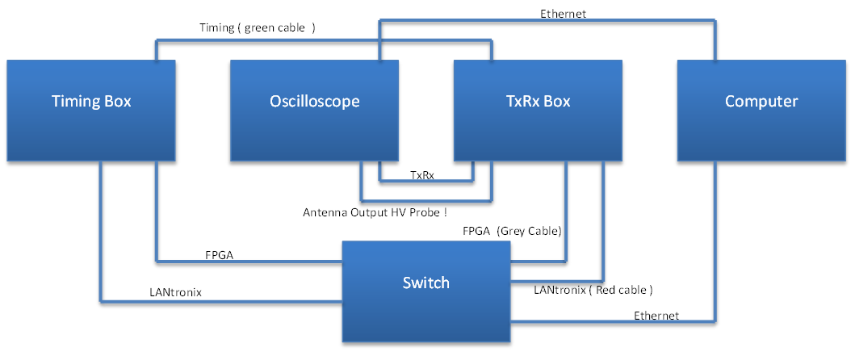

Figure . Transceiver test environment setup.

1. Navigate to /T3/cpart on the server.

## Transmit Test

How to do a transmit test

1. Ensure that there are 2 boxes alive
   1. Timing box
   2. Transceiver box being tested
2. Run ./sop
3. Select 1 for transmit test
4. Select 3 to start test
5. You should hear the box switching and see the TxRx signal as well as the antenna output (500 Vpp) on the oscilloscope and check that the count is increasing on the front panel.
6. To stop the test, enter 5.
7. Run ./sop and the press ctrl + c to reset the box.

## Receive Test

1. For the receive test, replace the dummy load with AWG set to 9.999 980 MHz @ 1 mVpp
2. DISCONNECT the signal generator cable from the actual machine, this is an extra safety to make sure you DON’T break the signal generator.
3. Run ./sop again and enter 0, then 3 to begin the transmit. (yes it says transmit but you are actually receiving)
4. Once you see a graph outputting on the PC screen, then attach the signal generator and the turn on the output.
5. This is again to make 100% sure you are not going to pump 1000 V into the signal generator.
6. When you switch on the AWG you should see a waveform on the computer with amplitude around 30 000 peak-to-peak
7. To stop the test, enter 5.
8. Run ./sop and then press ctrl+c to reset the box.

# Conclusion

This concludes the work instructions for testing a Fully Assembled SuperDARN Transeiver. The next step in the procedure for Servicing a SuperDARN Transceiver is calibration.